**No need to store files locally on your computer or network drive... OneDrive is here.**

OneDrive provides you with a secured Cloud-based location for file sharing and document management on Office 365 (O365).

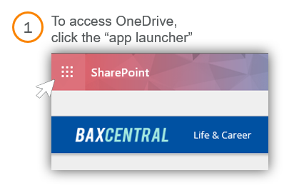To access OneDrive

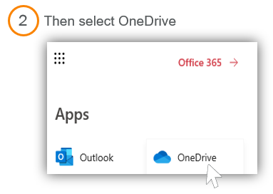

Top Features

* Share a document or an entire folder with both internal and external colleagues.
* Easy drag/drop allows you to move files from your computer to OneDrive.   
  (Note: Firefox and Chrome are the best browsers to use for this feature.)
* Supports 270 file types and up to 1TB of data per user.
* Integrated with O365 to allow for quick editing using Word, PowerPoint, and Excel on the desktop or web application.
* Collaborate with your colleagues simultaneously on a file using OneDrive.
* Automatic file versioning.